**Name:** Khot Aniket Tanaji  
**Batch & Roll:** A3-63

**Experiment No.3**

**Title:** To design an application using VideoView and WebView.

**PART A: Video View**

**MainActivity.java**

package com.example.expt3;  
  
import androidx.appcompat.app.AppCompatActivity;  
  
import android.content.Intent;  
import android.os.Bundle;  
import android.view.View;  
import android.widget.Button;  
  
public class MainActivity extends AppCompatActivity {  
  
 Button android;  
 Button webd;  
 @Override  
 protected void onCreate(Bundle savedInstanceState) {  
 super.onCreate(savedInstanceState);  
 setContentView(R.layout.*activity_main*);  
  
 android = findViewById(R.id.*androidbutton*);  
 webd = findViewById(R.id.*webdbutton*);  
  
 android.setOnClickListener(new View.OnClickListener() {  
 @Override  
 public void onClick(View view) {  
 Intent and = new Intent(MainActivity.this,AndroidTuts.class);  
 startActivity(and);  
 }  
 });  
  
 webd.setOnClickListener(new View.OnClickListener() {  
 @Override  
 public void onClick(View view) {  
 Intent web = new Intent(MainActivity.this,WebdTuts.class);  
 startActivity(web);  
 }  
 });  
  
 }  
}

**activity_main.xml**

<?xml version="1.0" encoding="utf-8"?>  
<androidx.constraintlayout.widget.ConstraintLayout xmlns:android="http://schemas.android.com/apk/res/android"  
 xmlns:app="http://schemas.android.com/apk/res-auto"  
 xmlns:tools="http://schemas.android.com/tools"  
 android:layout_width="match_parent"  
 android:layout_height="match_parent"  
 tools:context=".MainActivity">  
  
 <TextView  
 android:id="@+id/t1"  
 android:layout_width="wrap_content"  
 android:layout_height="wrap_content"  
 android:text="Welcome to Video Player"  
 android:textSize="30dp"  
 app:layout_constraintBottom_toTopOf="@+id/androidbutton"  
 app:layout_constraintEnd_toEndOf="parent"  
 app:layout_constraintStart_toStartOf="parent"  
 app:layout_constraintTop_toTopOf="parent" />  
  
 <Button  
 android:id="@+id/androidbutton"  
 android:layout_width="wrap_content"  
 android:layout_height="wrap_content"  
 android:layout_marginTop="248dp"  
 android:padding="20dp"  
 android:text="Android Tutorials"  
 app:layout_constraintEnd_toEndOf="parent"  
 app:layout_constraintStart_toStartOf="parent"  
 app:layout_constraintTop_toTopOf="parent" />  
  
 <Button  
 android:id="@+id/webdbutton"  
 android:layout_width="wrap_content"  
 android:layout_height="wrap_content"  
 android:layout_marginTop="108dp"  
 android:padding="20dp"  
 android:text="Web Dev Tutorials"  
 app:layout_constraintEnd_toEndOf="parent"  
 app:layout_constraintHorizontal_bias="0.502"  
 app:layout_constraintStart_toStartOf="parent"  
 app:layout_constraintTop_toBottomOf="@+id/androidbutton" />  
</androidx.constraintlayout.widget.ConstraintLayout>

**AndroidTuts.java**

package com.example.expt3;  
  
import androidx.appcompat.app.AppCompatActivity;  
  
import android.net.Uri;  
import android.os.Bundle;  
import android.view.View;  
import android.widget.Button;  
import android.widget.MediaController;  
import android.widget.VideoView;  
  
public class AndroidTuts extends AppCompatActivity {  
  
 Button b;  
 VideoView v;  
 MediaController c;  
 @Override  
 protected void onCreate(Bundle savedInstanceState) {  
 super.onCreate(savedInstanceState);  
 setContentView(R.layout.*activity_android_tuts*);  
  
 b = findViewById(R.id.*androidPlay*);  
 v = findViewById(R.id.*androidvideoView*);  
 c = new MediaController(AndroidTuts.this);  
  
 b.setOnClickListener(new View.OnClickListener() {  
 @Override  
 public void onClick(View view) {  
// String videoPath = "android.resource://com.example.expt3"+"/"+ R.raw.wildlife;  
 String videoPath = "android.resource://"+getPackageName()+"/"+ R.raw.*videoexp*;  
 Uri uri = Uri.*parse*(videoPath);  
 v.setVideoURI(uri);  
 v.setMediaController(c);  
  
 c.setAnchorView(v);  
 v.requestFocus();  
 v.start();  
  
 }  
 });  
 }  
}

**activity_android_tuts.xml**

<?xml version="1.0" encoding="utf-8"?>  
<androidx.constraintlayout.widget.ConstraintLayout xmlns:android="http://schemas.android.com/apk/res/android"  
 xmlns:app="http://schemas.android.com/apk/res-auto"  
 xmlns:tools="http://schemas.android.com/tools"  
 android:layout_width="match_parent"  
 android:layout_height="match_parent"  
 tools:context=".AndroidTuts">  
  
 <TextView  
 android:id="@+id/androidTitle"  
 android:layout_width="wrap_content"  
 android:layout_height="wrap_content"  
 android:layout_marginTop="64dp"  
 android:text="Android Tutorials"  
 android:textSize="30dp"  
 app:layout_constraintEnd_toEndOf="parent"  
 app:layout_constraintHorizontal_bias="0.497"  
 app:layout_constraintStart_toStartOf="parent"  
 app:layout_constraintTop_toTopOf="parent" />  
  
 <VideoView  
 android:id="@+id/androidvideoView"  
 android:layout_width="400dp"  
 android:layout_height="350dp"  
 android:layout_marginTop="40dp"  
 app:layout_constraintEnd_toEndOf="parent"  
 app:layout_constraintHorizontal_bias="0.454"  
 app:layout_constraintStart_toStartOf="parent"  
 app:layout_constraintTop_toBottomOf="@+id/androidTitle" />  
  
 <Button  
 android:id="@+id/androidPlay"  
 android:layout_width="wrap_content"  
 android:layout_height="wrap_content"  
 android:layout_marginTop="52dp"  
 android:paddingLeft="15dp"  
 android:paddingTop="10dp"  
 android:paddingRight="15dp"  
 android:paddingBottom="10dp"  
 android:text="Play"  
 android:textSize="20dp"  
 app:layout_constraintEnd_toEndOf="parent"  
 app:layout_constraintHorizontal_bias="0.498"  
 app:layout_constraintStart_toStartOf="parent"  
 app:layout_constraintTop_toBottomOf="@+id/androidvideoView" />  
</androidx.constraintlayout.widget.ConstraintLayout>

**WebTuts.java**

package com.example.expt3;  
  
import androidx.appcompat.app.AppCompatActivity;  
  
import android.net.Uri;  
import android.os.Bundle;  
import android.view.View;  
import android.widget.Button;  
import android.widget.MediaController;  
import android.widget.VideoView;  
  
public class WebdTuts extends AppCompatActivity {  
  
 Button b;  
 VideoView v;  
 MediaController c;  
  
 @Override  
 protected void onCreate(Bundle savedInstanceState) {  
 super.onCreate(savedInstanceState);  
 setContentView(R.layout.activity_webd_tuts);  
  
 b = findViewById(R.id.webdPlay);  
 v = findViewById(R.id.webvideoView);  
 c = new MediaController(WebdTuts.this);  
  
 b.setOnClickListener(new View.OnClickListener() {  
 @Override  
 public void onClick(View view) {  
 String videoPath = "android.resource://"+getPackageName()+"/"+ R.raw.videoexp;  
 Uri uri = Uri.parse(videoPath);  
 v.setVideoURI(uri);  
 v.setMediaController(c);  
 c.setAnchorView(v);  
 v.requestFocus();  
 v.start();  
 }  
 });  
 }  
}

**activity_webd_tuts.xml**

<?xml version="1.0" encoding="utf-8"?>  
<androidx.constraintlayout.widget.ConstraintLayout xmlns:android="http://schemas.android.com/apk/res/android"  
 xmlns:app="http://schemas.android.com/apk/res-auto"  
 xmlns:tools="http://schemas.android.com/tools"  
 android:layout_width="match_parent"  
 android:layout_height="match_parent"  
 tools:context=".WebdTuts">  
  
 <TextView  
 android:id="@+id/textView"  
 android:layout_width="wrap_content"  
 android:layout_height="wrap_content"  
 android:layout_marginTop="108dp"  
 android:text="Webd Tutorials"  
 android:textSize="30dp"  
 app:layout_constraintEnd_toEndOf="parent"  
 app:layout_constraintStart_toStartOf="parent"  
 app:layout_constraintTop_toTopOf="parent" />  
  
 <VideoView  
 android:id="@+id/webvideoView"  
 android:layout_width="300dp"  
 android:layout_height="200dp"  
 android:layout_marginTop="80dp"  
 app:layout_constraintEnd_toEndOf="parent"  
 app:layout_constraintHorizontal_bias="0.495"  
 app:layout_constraintStart_toStartOf="parent"  
 app:layout_constraintTop_toBottomOf="@+id/textView" />  
  
 <Button  
 android:id="@+id/webdPlay"  
 android:layout_width="wrap_content"  
 android:layout_height="wrap_content"  
 android:layout_marginTop="96dp"  
 android:paddingLeft="15dp"  
 android:paddingTop="10dp"  
 android:paddingRight="15dp"  
 android:paddingBottom="10dp"  
 android:text="Play"  
 android:textSize="20dp"  
 app:layout_constraintEnd_toEndOf="parent"  
 app:layout_constraintHorizontal_bias="0.498"  
 app:layout_constraintStart_toStartOf="parent"  
 app:layout_constraintTop_toBottomOf="@+id/webvideoView" />  
</androidx.constraintlayout.widget.ConstraintLayout>

**Output:-**

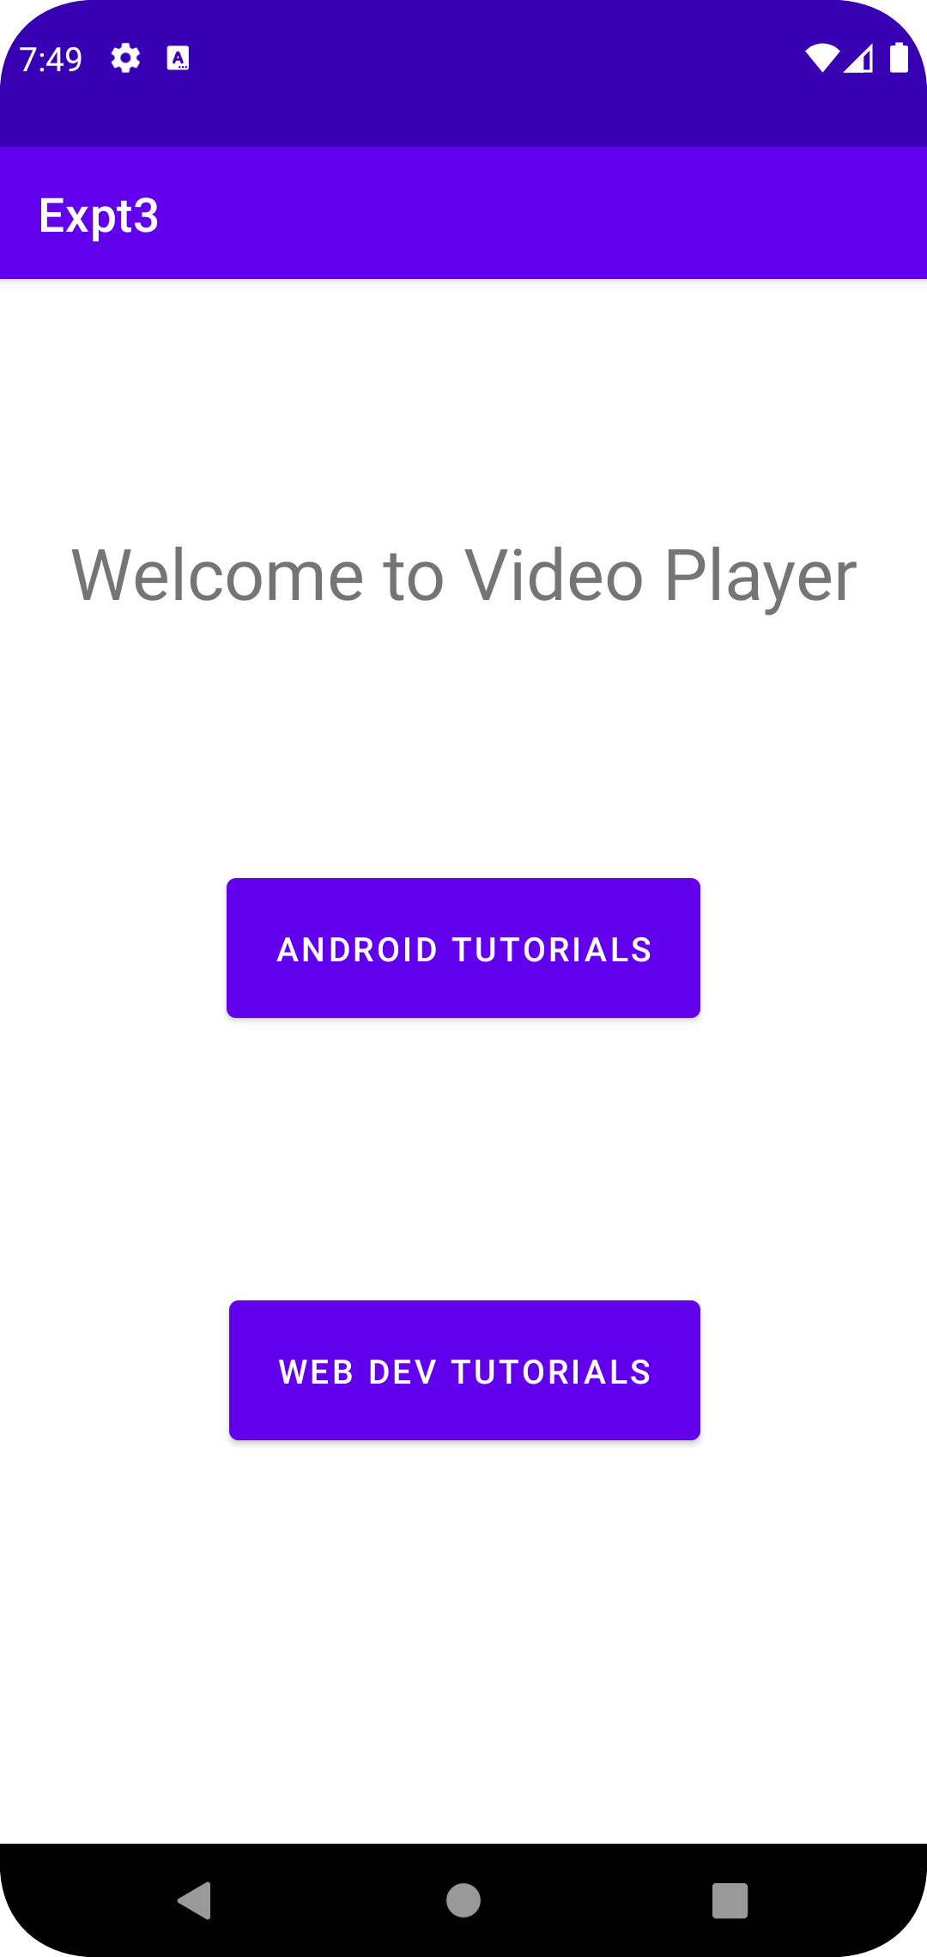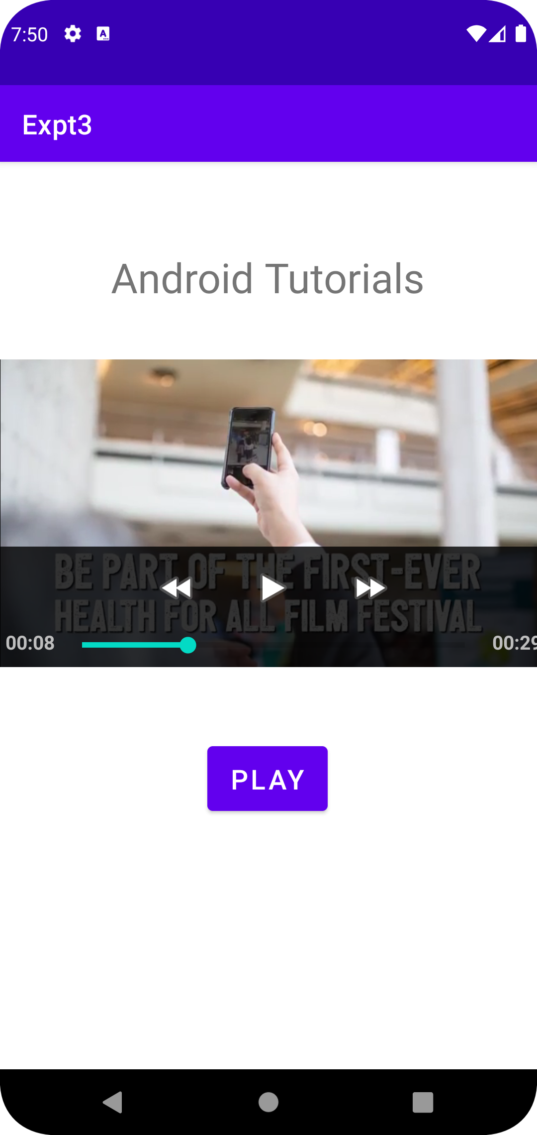

**PART B: Web View**

**MainActivity.java**

package com.example.exptpartb;  
  
import androidx.appcompat.app.AppCompatActivity;  
  
import android.content.Intent;  
import android.os.Bundle;  
import android.view.View;  
import android.widget.Button;  
  
public class MainActivity extends AppCompatActivity {  
  
 Button b;  
 @Override  
 protected void onCreate(Bundle savedInstanceState) {  
 super.onCreate(savedInstanceState);  
 setContentView(R.layout.*activity_main*);  
  
 b=findViewById(R.id.*clickHereButton*);  
 b.setOnClickListener(new View.OnClickListener(){  
 public void onClick(View view){  
 Intent i= new Intent(MainActivity.this,WebViewContainer.class);  
 startActivity(i);  
 }  
 });  
 }  
}

**activity_main.xml**

<?xml version="1.0" encoding="utf-8"?>  
<androidx.constraintlayout.widget.ConstraintLayout xmlns:android="http://schemas.android.com/apk/res/android"  
 xmlns:app="http://schemas.android.com/apk/res-auto"  
 xmlns:tools="http://schemas.android.com/tools"  
 android:layout_width="match_parent"  
 android:layout_height="match_parent"  
 tools:context=".MainActivity">  
  
 <TextView  
 android:id="@+id/titles"  
 android:layout_width="wrap_content"  
 android:layout_height="wrap_content"  
 android:layout_marginTop="156dp"  
 android:text="Web View Demo Application"  
 android:textSize="30dp"  
 app:layout_constraintEnd_toEndOf="parent"  
 app:layout_constraintStart_toStartOf="parent"  
 app:layout_constraintTop_toTopOf="parent" />  
  
 <Button  
 android:id="@+id/clickHereButton"  
 android:layout_width="wrap_content"  
 android:layout_height="wrap_content"  
 android:layout_marginTop="308dp"  
 android:text="Click here"  
 app:layout_constraintEnd_toEndOf="parent"  
 app:layout_constraintHorizontal_bias="0.498"  
 app:layout_constraintStart_toStartOf="parent"  
 app:layout_constraintTop_toBottomOf="@+id/titles" />  
  
</androidx.constraintlayout.widget.ConstraintLayout>

**WebViewContainer.java**

package com.example.exptpartb;  
  
import androidx.appcompat.app.AppCompatActivity;  
  
import android.os.Bundle;  
import android.view.View;  
import android.webkit.WebView;  
import android.webkit.WebViewClient;  
import android.widget.Button;  
import android.widget.EditText;  
  
public class WebViewContainer extends AppCompatActivity {  
  
 Button b;  
 WebView wv;  
 EditText ed;  
  
 @Override  
 protected void onCreate(Bundle savedInstanceState) {  
 super.onCreate(savedInstanceState);  
 setContentView(R.layout.*activity_web_view_container*);  
  
 b=findViewById(R.id.*urlButton*);  
 wv=findViewById(R.id.*webView*);  
 ed=findViewById(R.id.*enterURL*);  
  
 wv.setWebViewClient(new MyBrowser());  
 b.setOnClickListener(new View.OnClickListener() {  
 @Override  
 public void onClick(View view) {  
 String url =ed.getText().toString();  
 wv.getSettings().setLoadsImagesAutomatically(true);  
 wv.getSettings().setJavaScriptEnabled(true);  
 wv.setScrollBarStyle(View.*SCROLLBARS_INSIDE_OVERLAY*);  
 wv.loadUrl(url);  
 }  
 });  
 }  
}  
  
class MyBrowser extends WebViewClient {  
 @Override  
 public boolean shouldOverrideUrlLoading(WebView view, String url) {  
 view.loadUrl(url);  
 return super.shouldOverrideUrlLoading(view, url);  
 }  
}

**activity_web_view_container.xml**

<?xml version="1.0" encoding="utf-8"?>  
<androidx.constraintlayout.widget.ConstraintLayout xmlns:android="http://schemas.android.com/apk/res/android"  
 xmlns:app="http://schemas.android.com/apk/res-auto"  
 xmlns:tools="http://schemas.android.com/tools"  
 android:layout_width="match_parent"  
 android:layout_height="match_parent"  
 tools:context=".WebViewContainer">  
  
 <EditText  
 android:id="@+id/enterURL"  
 android:layout_width="wrap_content"  
 android:layout_height="wrap_content"  
 android:layout_marginTop="40dp"  
 android:ems="10"  
 android:hint="Enter a valid URL"  
 android:inputType="textPersonName"  
 android:minHeight="48dp"  
 app:layout_constraintEnd_toEndOf="parent"  
 app:layout_constraintHorizontal_bias="0.497"  
 app:layout_constraintStart_toStartOf="parent"  
 app:layout_constraintTop_toTopOf="parent" />  
  
 <Button  
 android:id="@+id/urlButton"  
 android:layout_width="wrap_content"  
 android:layout_height="wrap_content"  
 android:layout_marginTop="40dp"  
 android:text="Search"  
 app:layout_constraintEnd_toEndOf="parent"  
 app:layout_constraintStart_toStartOf="parent"  
 app:layout_constraintTop_toBottomOf="@+id/enterURL" />  
  
 <WebView  
 android:id="@+id/webView"  
 android:layout_width="413dp"  
 android:layout_height="450dp"  
 android:layout_marginBottom="36dp"  
 app:layout_constraintBottom_toBottomOf="parent"  
 app:layout_constraintEnd_toEndOf="parent"  
 app:layout_constraintHorizontal_bias="0.0"  
 app:layout_constraintStart_toStartOf="parent"  
 app:layout_constraintTop_toBottomOf="@+id/urlButton"  
 app:layout_constraintVertical_bias="1.0" />  
</androidx.constraintlayout.widget.ConstraintLayout>

**Output:-**

